**Project 3**

**Integrate Grafana with Linux Server for high cpu utilization and create a graph in Grafana**

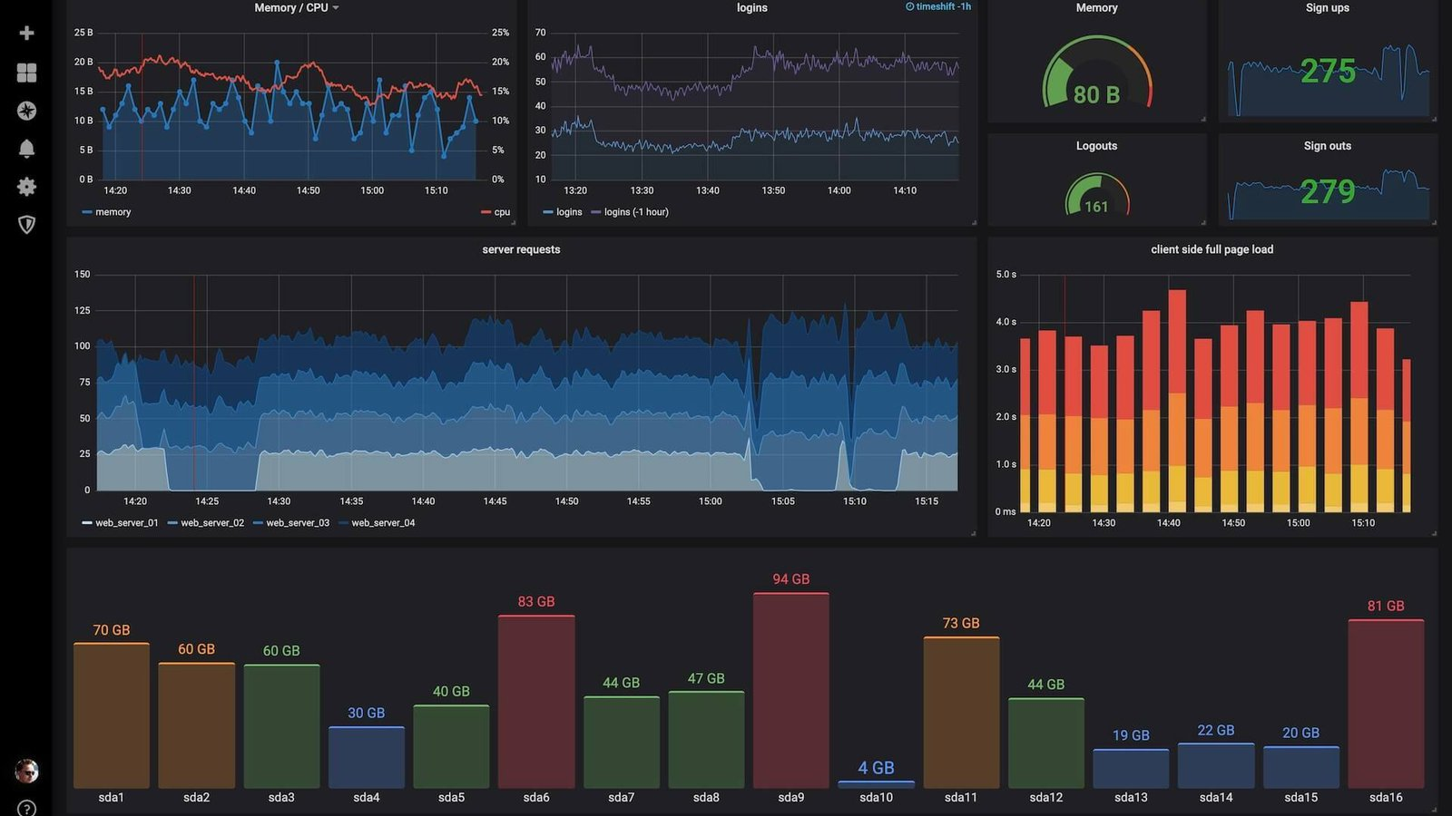

**GRAFANA :** Grafana is an [open source](https://www.redhat.com/en/topics/open-source/what-is-open-source) interactive data-visualization platform, developed by [Grafana Labs](https://www.grafana.com/), which allows users to see their data via charts and graphs that are unified into one dashboard (or multiple dashboards!) for easier interpretation and understanding. You can also query and set alerts on your information and metrics from wherever that information is stored, whether that’s traditional server environments, [Kubernetes clusters](https://www.redhat.com/en/topics/containers/what-is-a-kubernetes-cluster), or various [cloud services](https://www.redhat.com/en/topics/cloud-computing/what-are-cloud-services), etc. You’re then more easily able to analyze the data, identify trends and inconsistencies, and ultimately make your processes more efficient. Grafana was built on open principles and the belief that data should be accessible throughout an organization, not just to a small handful of people. This fosters a culture where data can be easily found and used by anyone who needs it, empowering teams to be more open, innovative, and collaborative.

**Step 1: install grafana**

Now we will install Grafana. If you wish to actually test Grafana skip to Section Two below before you install.

sudo yum install grafana –y

The next command will reload the system

sudo systemctl daemon-reload

Then we will start our server and check our service with the following two commands.

sudo systemctl start grafana-server

sudo systemctl status grafana-server

**Step 2: create EC2 instance**

• Go to EC2

• Create EC2

• Choose a public subnet

* Give it our Grafana security group
* Now SSH into our instance

• Update your packages with

sudo yum update –y

We need to add a repository for grafana so our OS will know where it is.

sudo nano /etc/yum.repos.d/grafana.rep

**Step 3:Test Grafana**

To test our server we will need to grab our public IPv4 and add a :3000 at the end, ie. 10.90.80.10:3000, and insert it into our browser URL. This will bring you to a login screen and our Username and Password will be admin. You will be prompted to create a new password

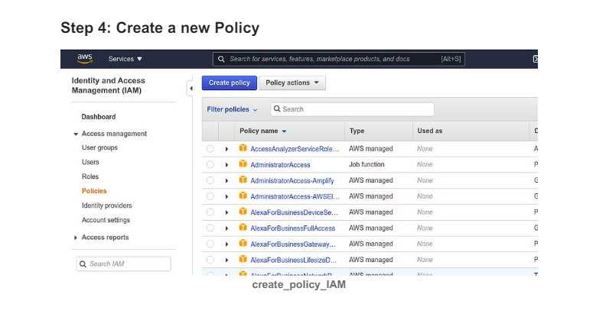

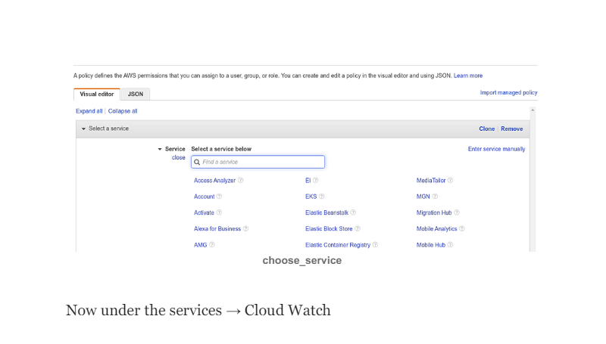

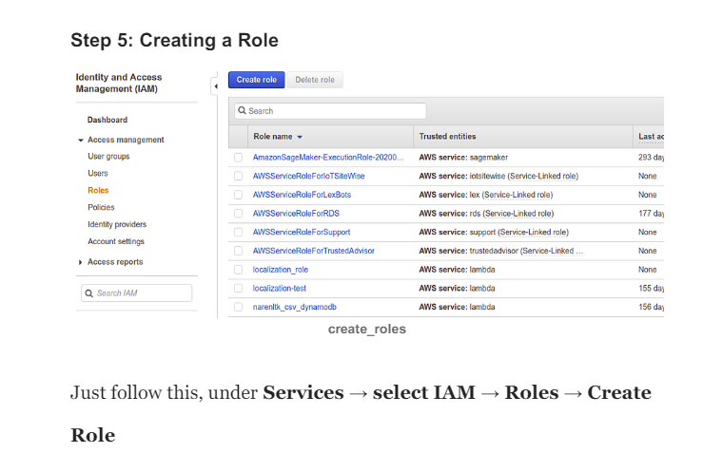

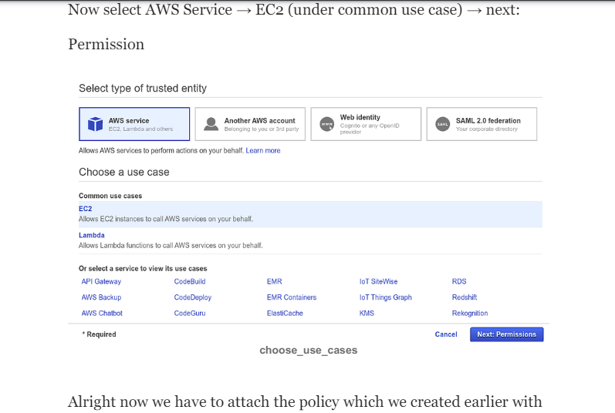

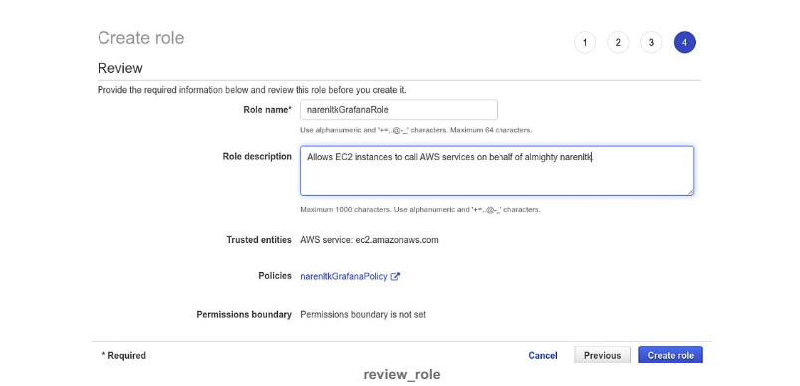

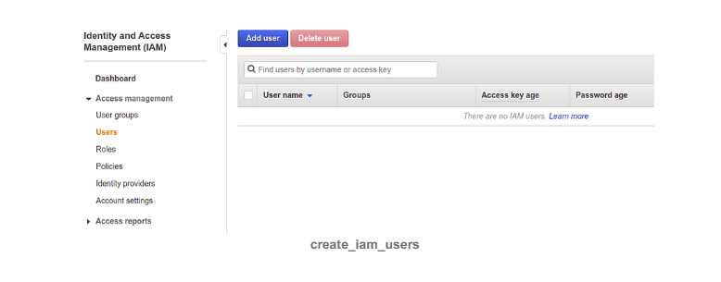

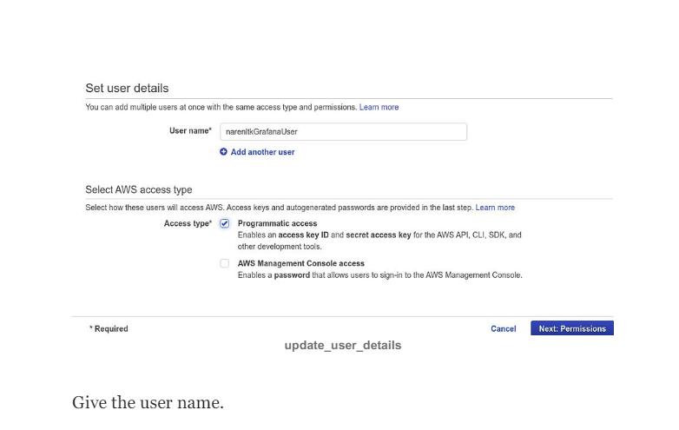

Now log into to your Grafana Dashboard, with uname and pwd which you have configured, Note:Default uname and pwd is given below Uname → admin

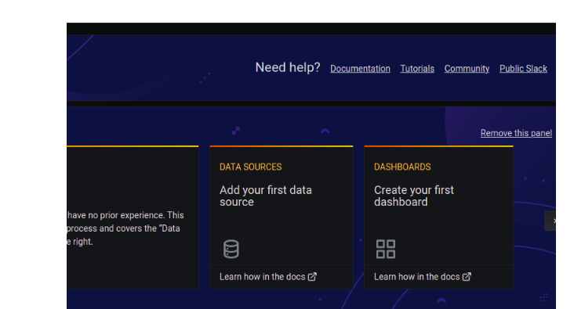

**ADD DATA SOURCE**

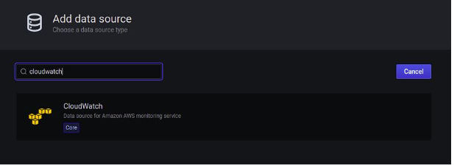

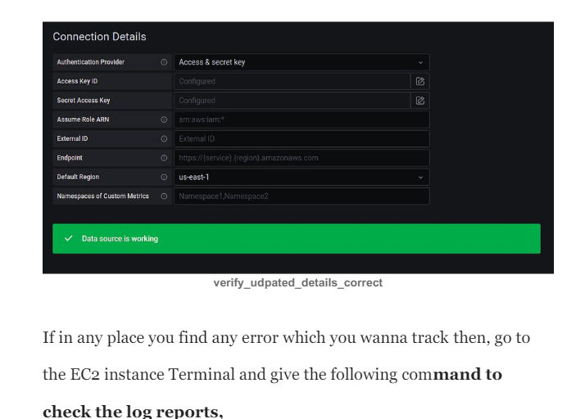

**CPU UTILISATION**

